Replacing a Side Cover Gasket
My 1989 FJ62 has 254,000 miles, which is plenty for various gaskets to have failed once or twice. This truck has the 3F-E engine, a far-removed descendent of the 1950s-era straight 6 engines upon which it is based. After replacing the oil pan gasket, I still had a slight leak at the lower right side of the engine. The dreaded side cover gasket was oozing. The side cover is the steel plate that covers the valve lifter galley, extending the entire length of the engine. Murphy’s Law says that this won’t be an easy gasket to replace (although easier than the rear main seal, at least).
To remove the side cover itself, you have to get it out of the engine compartment – no small feat. On this truck, the side cover is trapped on the rear by the firewall, on the front by the A/C compressor bracket, and on the outside by the distributor, oil filter, and cooling system hard lines. It’s 1930s technology trapped by 50 years of vehicle improvements and changes. It’s probably a snap to change on an FJ25…but this is an FJ62.
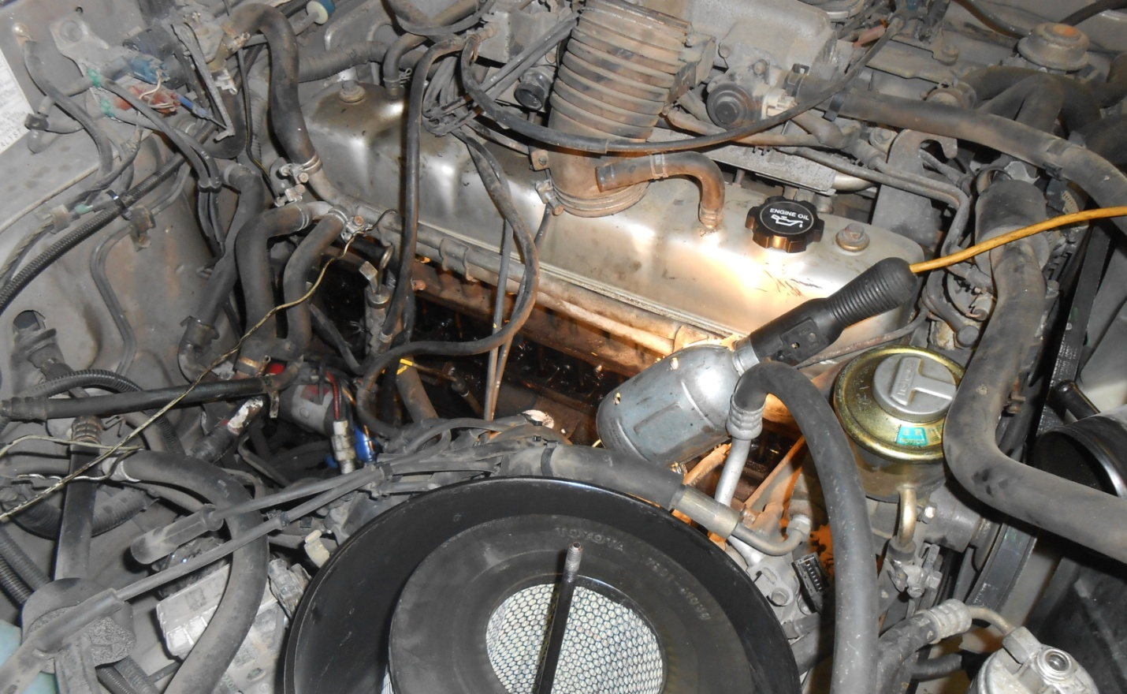
The area in which you’ll be working to fix this leak
I didn’t follow the factory service manual procedure (I couldn’t find one in my non-US market service manual anyway), but that is rumored to require removing the A/C compressor bracket, which is a major inconvenience. I figured there must be a way to sneak the cover out without such work. There may be a miracle method out there, but the steps I used are:
- Place a milk crate by the right front tire so you can stand on it and effectively work in this area of the engine compartment.
- Remove the air intake system to gain access to the general area.
- Remove the distributor cap and all spark plug wires from the plugs – leave them on the cap.
- Remove the oil filter and clean up the mess, cover the filter base with a rag.
- Note where the distributor rotor is pointing, mark it or take a photo – you’ll need this later.
- Remove the distributor clamp bolt, unplug the distributor wiring connector, and with a 2x2 wood stick and a hammer, tap out the distributor from below the truck to remove it. I was unable to remove the distributor with my bare hands. Cover distributor hole with rag.
- Remove two of the engine hook bolts (not the hook itself) on the right side of the block.
- Unbolt the banjo fitting at the fuel filter to loosen the fuel line, which blocks cover removal.
- Move any other wiring or vacuum hoses out of the way.
- Remove the bolts and two nuts that retain the side cover.
- Gently pry the cover loose from the block and extract the cover while using creative language and questioning the intelligence of Toyota engineers.

Here’s where the fun begins. You will find that the side cover, when slid back to the firewall, won’t clear the A/C bracket. When slid forward, it won’t clear the engine hook, fuel line, or cooling system lines. At this point, you take a break and put on your thinking cap. After much study, I decided to flex the cover out past the engine hook, and around the fuel line, and slide the back edge up toward the valve cover.
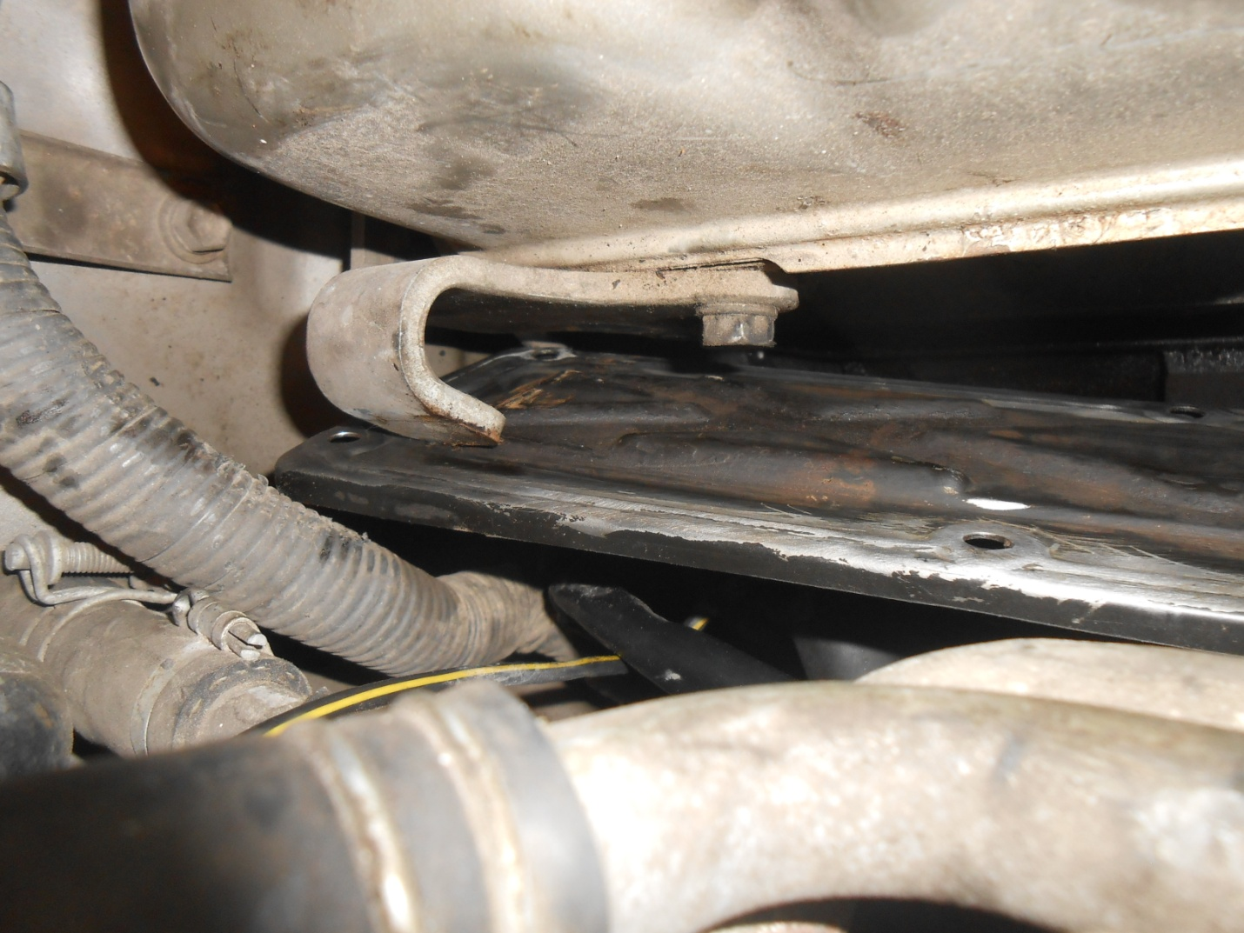
Sneaking the cover past the rear engine hook

It is still trapped behind the cooling system lines and the hood. When you have gotten the cover high enough, you can tilt the cover, and get it to start falling down at the front of the engine.
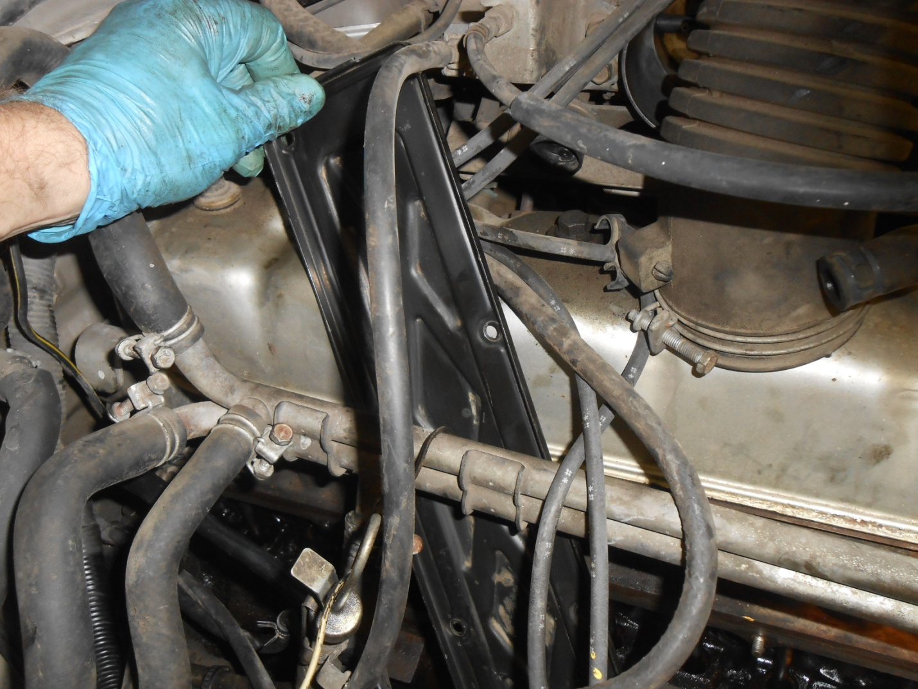
Pulling the cover up through the engine compartment inside the cooling system lines before lowering the cover through the suspension to the floor to clear those same cooling lines
Eventually, I was able to drop the front end of the cover down below the engine toward the front axle, and get the cover vertical. At this point I could lift it up and out of the engine compartment. I did not distort or bend the cover during this removal process, but it grazes many surfaces as you slide it out.
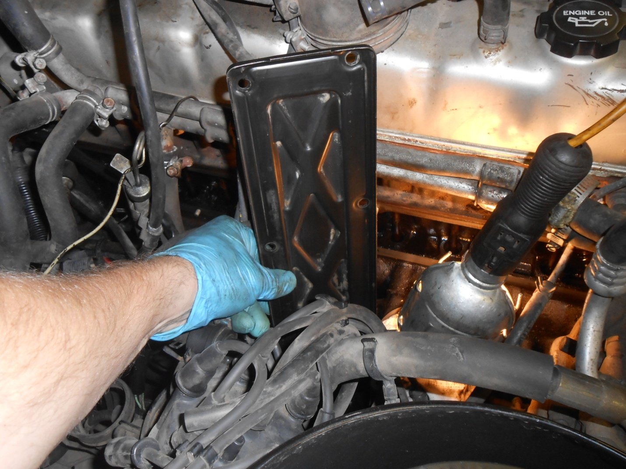
Pulling the cover up through the engine compartment outside the cooling system lines, which is key to removing the cover from the truck

With the side cover out, I used a stiff putty knife and remove much of the crispy gasket from the cover. I then put a Scotchbrite pad on my die grinder, and spent a solid hour removing the baked-on gasket bits. Finally, the gasket face was clean. I used brake cleaner to clean the face of the cover, and then with a hammer, tapped each bolt hole flat to improving sealing. These holes are typically distorted from the bolts being over-tightened.
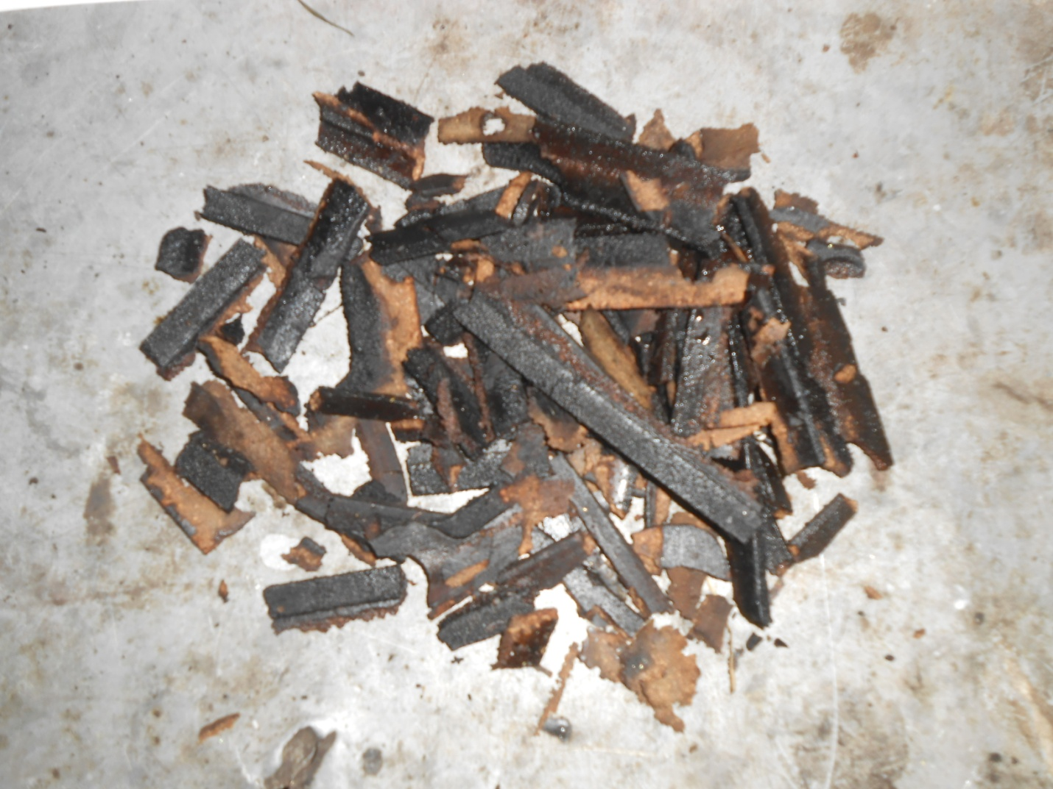
The old gasket lacked a certain pliability!
On to the engine block sealing face - I used my putty knife, and a razor blade (welded to a screwdriver tip) to clean the block face. Being cast iron, you can scrape aggressively without fear of damaging it. Access is terrible, and I used a mirror and flashlight to clean the portion behind the A/C compressor bracket.
With a clean cover, clean block, and new OEM gasket, I was ready to reassemble. I cut the heads off two metric bolts to create two additional studs over which to hang the gasket on the block. A gasket would never survive being caulked to the cover, given how much manipulation is required to get the cover back up against the engine. I suppose you could caulk the gasket to the block, but access to the area is still an issue.
Bringing the cover back to the engine is the reverse of removal. When I had the cover adjacent to the block, I hung the new gasket on my four studs. The gasket sagged at the bottom, but this can be fixed later. I set the cover on front of the engine, hung it on the studs, and then aligned the gasket behind the cover. You have to fiddle with the gasket and holes and use an ice pick to coax the gasket holes to line up with the cover.
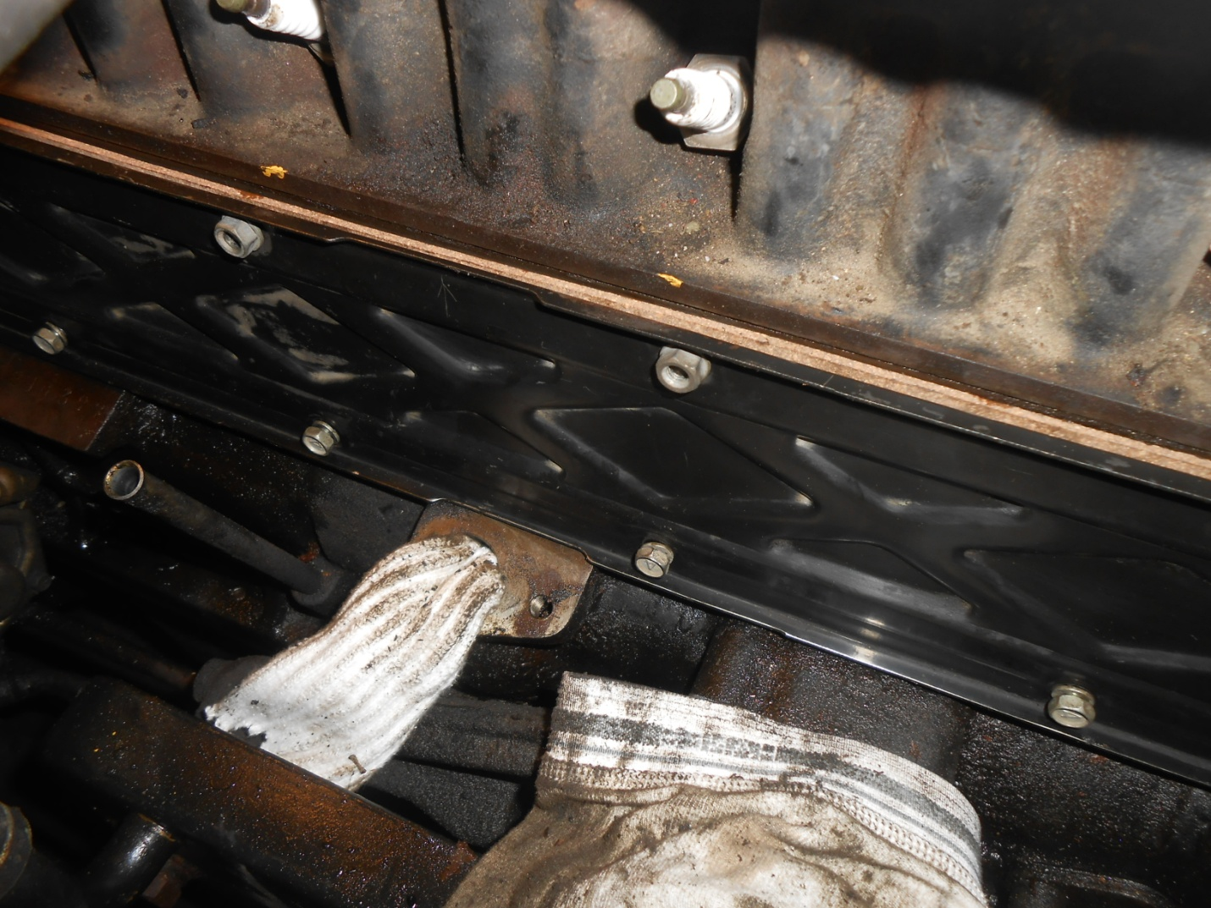
Cover reinstalled with a new gasket and bolts/nuts loosely installed
Finally, I removed my two studs, and installed all the factory bolts, and tightened them to 34 inch-pounds (not lb-ft).
Total time for this repair was about 9 hours – but I work methodically (because I’m old and forget things) – 3 hours for the teardown and cover removal, 3 hours of cleaning time (cleaning the block, cover, distributor, oil cooler, bolts), and 3 hours to reassemble. Part of reassembly is carefully reinstalling the distributor, being very certain that it is fully seated in the block, as this drives the oil pump. You must also realign the rotor so that the timing is nearly correct. I installed a new oil filter, and all the engine wiring, fuel line and intake bits. Finally, I started the truck, and adjusted the ignition timing, per the factory procedure. My engine now idles faster and smoother, so I believe the timing hasn’t been correct for years. An unexpected bonus!
Weeks later, the cover is leak free. You may choose to hire out this sort of work, but if you do, you’ll have an appreciation of why the repair is expensive, in either time or money.

